1. Assignment 10

You have to create three pages ‘about us’, ‘register’ and ‘login’. It will have a navigation bar. Which will redirect to the pages.

1. Our app will have 3 pages (home , About Us , login)
2. From navbar by clicking the page name we will redirect to respective pages .

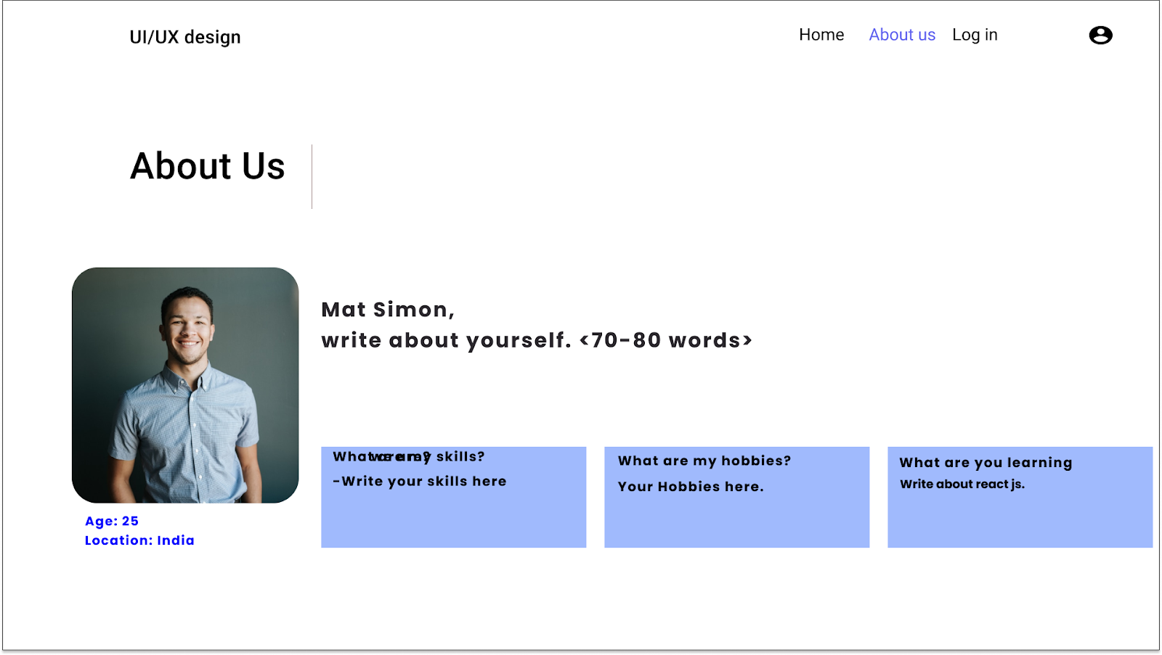

**FIGURE : HOMEPAGE DESIGN**

**Create About page design by your own**

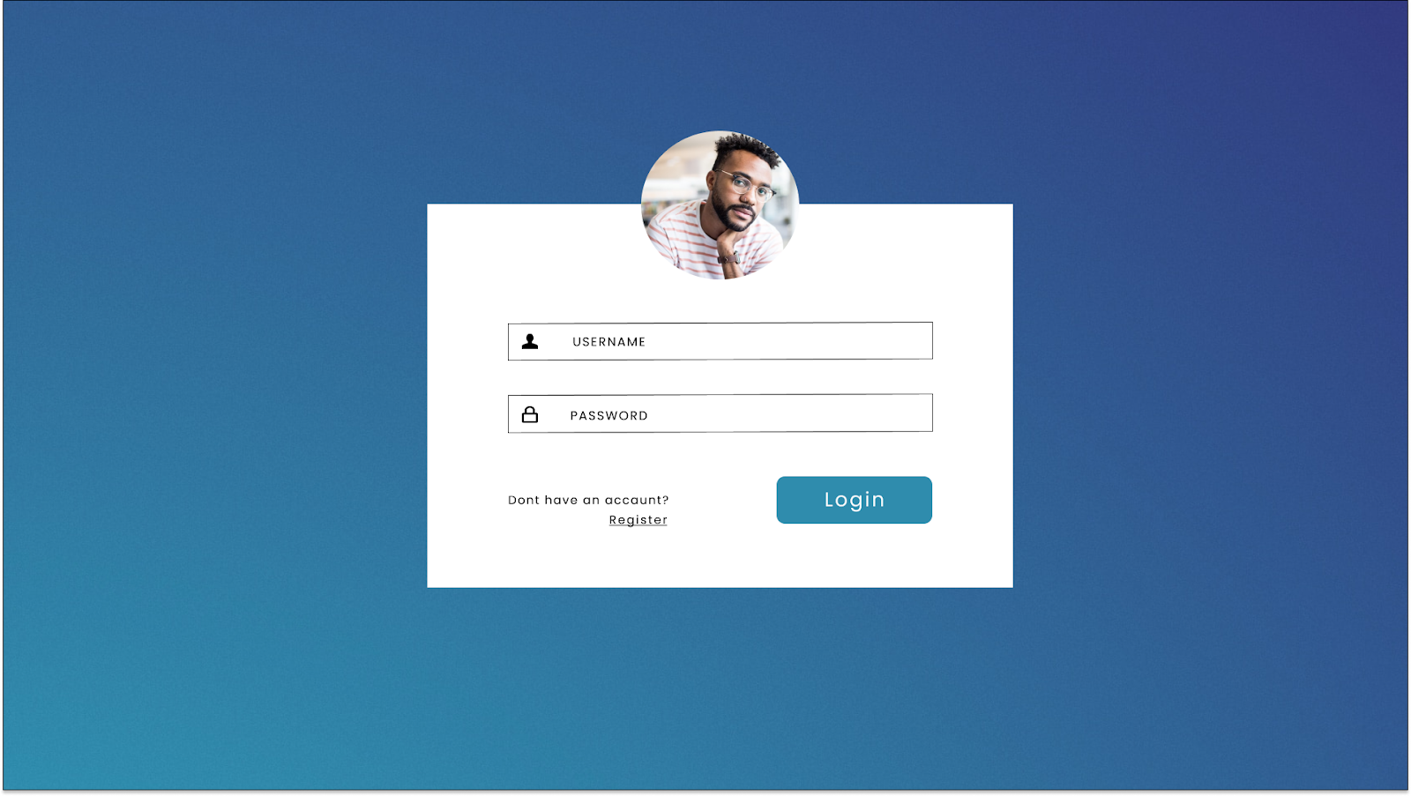

FIGURE : LOGIN COMPONENT AT (LOGIN PAGE)

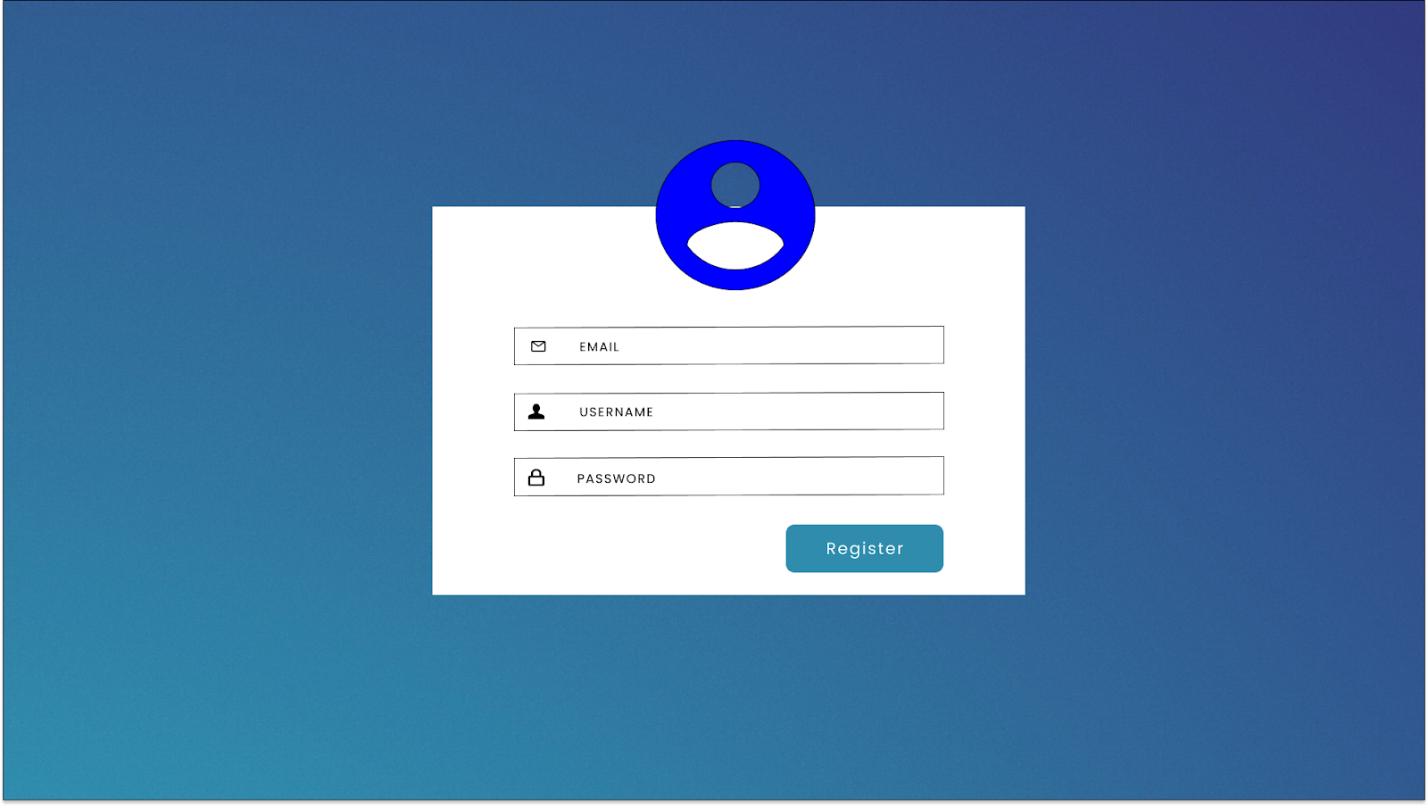

FIGURE : REGISTRATION COMPONENT AT (LOGIN PAGE)

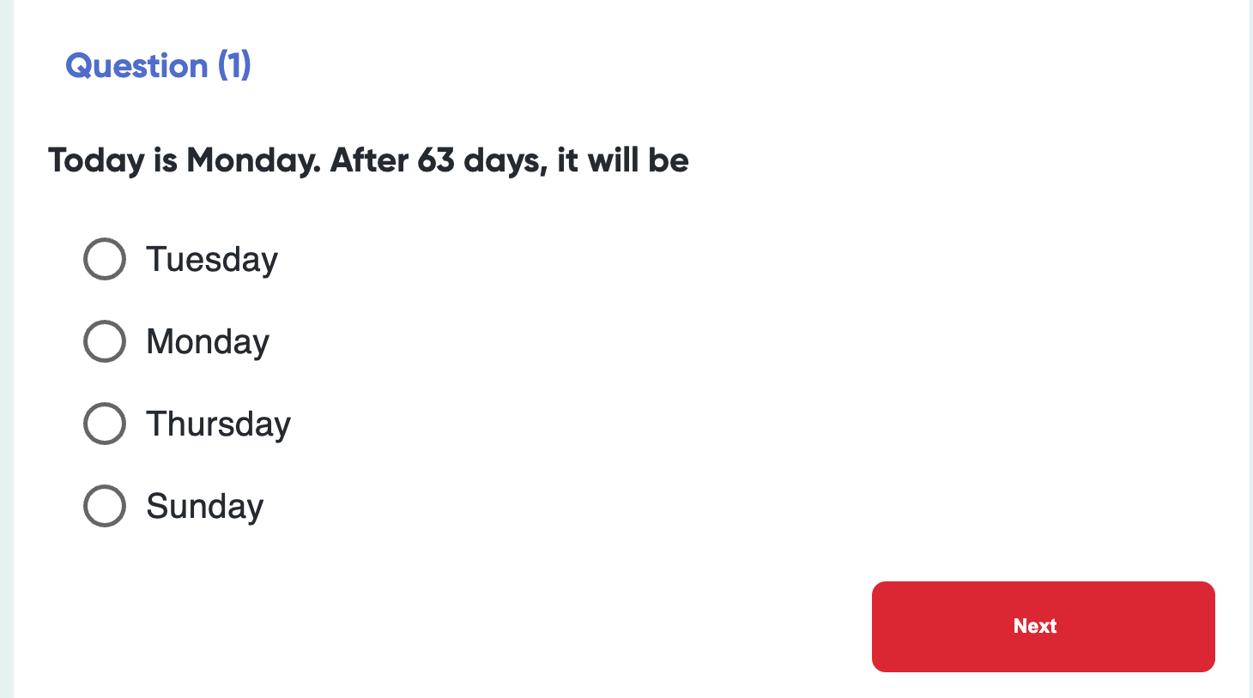

1. Create the test of 10 questions
2. Each question has 4 option
3. Save the selected option using useRef .
4. On click next we will show the next question .
5. When there is a 10th question button text will change from ‘next’ -/> ‘Submit’ .
6. On submitting last question we will , we will display the result
7. Each question will have 2 marks and passing marks will be 12 out of 20 .
8. On passing the test show greeting .
9. On failing the test show button to restart the test .

Const questionsData = [

{

Question : ‘’,

Options : [1,2,3,4],

Correct answer : ‘’

}

]

Keep data format as above